# VISVESVARAYA TECHNOLOGICAL UNIVERSITY

## BELAGAVI – 590018, Karnataka INTERNSHIP REPORT

#### ON

“FULL STACK DEVELOPMENT”

***Submitted in partial fulfilment for the award of degree(18CSI85)***

## BACHELOR OF ENGINEERING

## IN

## COMPUTER SCIENCE AND ENGINEERING

***Submitted by:***

#### PREM KUMAR GHISING

#### 1BH20CS024

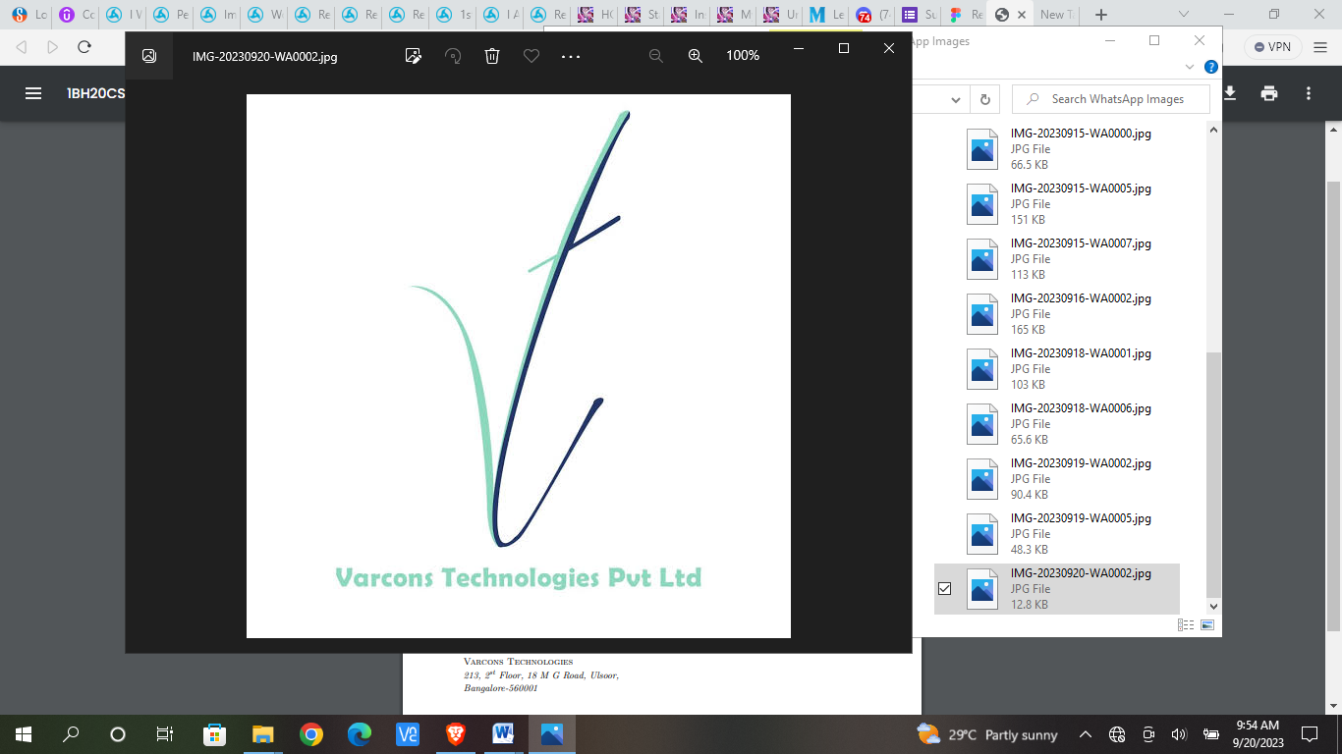

Conducted at

 **VARCONS Technologies Pvt Ltd**

**BANGALORE TECHNOLOGICAL INSTITUTE**

**(ISO 9001:2015 Certified Institute) Sarjapura Road,Kodathi,**

**Bangalore-560035**

**Department of Computer Science & Engineering**

**BANGALORE TECHNOLOGICAL INSTITUTE**

**(ISO 9001:2015 Certified Institute) Sarjapura Road,Kodathi,**

**Bangalore-560035**

**Department of Computer Science & Engineering**

# 

**CERTIFICATE**

This is to certify that the Internship titled **“FULL STACK DEVELOPMENT”** carried out by **Mr. Prem Kumar Ghising,** a bonafide student of abc Institute of Technology, in partial fulfillment for the award of **Bachelor of Engineering**, in **CSE** under Visvesvaraya Technological University, Belagavi, during the year 2022-2023. It is certified that all corrections/suggestions indicated have been incorporated in the report.

The project report has been approved as it satisfies the academic requirements in respect of Internship prescribed for the course Internship / Professional Practice (18CSI85)

#### Signature of Guide Signature of HOD Signature of Principal

**External Viva:**

Name of the Examiner Signature with Date

1)

2)

# D E C L A R A T I O N

I, **Prem Kumar Ghising**, final year student of Computer Science and Engineering, **Bangalore Technological Institute** - 560 035, declare that the Internship has been successfully completed, in **VARCONS TECHNOLOGIES**. This report is submitted in partial fulfillment of the requirements for award of Bachelor Degree in Branch name, during the academic year 2022-2023.

Date :20-09-2023 :

Place : Bangalore

USN : 1BH20CS024

NAME : PREM KUMAR GHISING

**OFFER LETTER PROVIDED BY THE COMPANY**

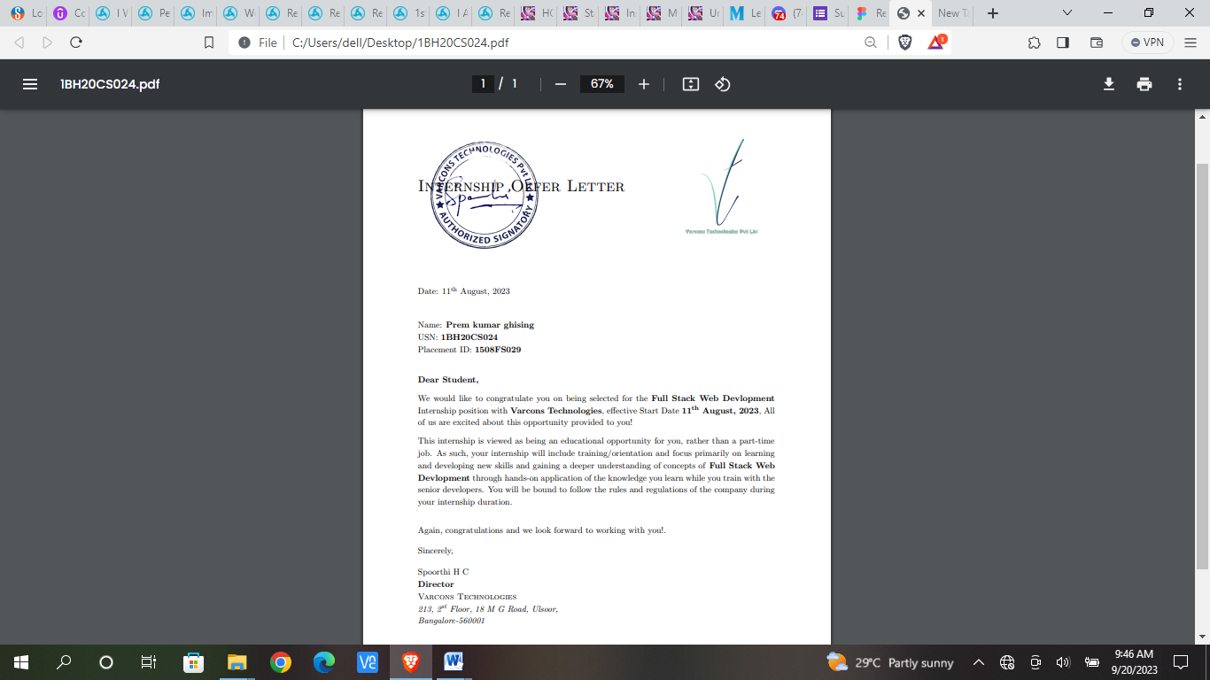

# A C K N O W L E D G E M E N T

Any achievement, be it scholastic or otherwise does not depend solely on the individual efforts but on the guidance, encouragement and cooperation of intellectuals and elders. We would like to take this opportunity to thank them all.

We heartily extend our words of gratitude to our guide, Asst Professor **Mr SUDHAKAR K**, for her valuable advice, encouragement and suggestion given to us in the course of our mini-project work. We convey our gratitude to her for having constantly monitored the development of the mini- project and setting up precise deadlines.

We would like to express my immense gratitude to head of department **Dr.** **SREERAMAREDDY**, for his unfailing encouragement and suggestions given to me in the course of the work.

We would like to take this opportunity to express our gratitude to the Principal, Dr. H S NANDA, for giving us this opportunity to enrich our knowledge.

We are grateful to the President **Dr**. **A Prabhakara Reddy** and Secretary, **Sri. C LGowda** for having provided us with a great infrastructure and well-furnished labs.

Finally, a note of thanks to the Department of Computer Science and Engineering, both teaching and non-teaching staff for their cooperation extended to us.

Last but not the least, we acknowledge the support and feedback of our parents, guardians and friends, for their indispensable help always..

**NAME:PREM KUMER GHISING**

**USN:1BH20CS024**

# ABSTRACT

Absolutely, crafting a compelling abstract for a tech startup landing page is crucial to capture attention and convey the essence of your startup. Here's a sample abstract for a tech startup landing page:

Our passion is to revolutionize the way you experience [Industry] by integrating cutting-edge technology and intuitive design.

we're committed to describe your startup's mission and objective]. Our innovative solutions are tailored to enhance Industry journey, providing seamless experiences and exceptional outcomes.

Key Highlights:

Innovative Solutions: Explore our game-changing products that leverage the latest advancements in technology to transform Industry.

User-Centric Design: Immerse yourself in elegant designs meticulously crafted to delight users and offer unparalleled usability.

Reliable Performance: Count on our solutions for a robust and consistent performance, designed to meet the demands of Industry.

# Table of Contents

|  |  |  |
| --- | --- | --- |
| **Sl no** | **Description** | **Page no** |
| 1 | Company Profile | 8 |
| 2 | About the Company | 10 |
| [3](https://1.bp.blogspot.com/-dODuK8N5h1Q/Wlnyb3V9HFI/AAAAAAAACL4/WxQtCJ1pM5wccDABg4wIrTBUB0vlikXQQCLcBGAs/s1600/poly1.jpg) | Introduction | 14 |
| [4](https://1.bp.blogspot.com/-dODuK8N5h1Q/Wlnyb3V9HFI/AAAAAAAACL4/WxQtCJ1pM5wccDABg4wIrTBUB0vlikXQQCLcBGAs/s1600/poly1.jpg) | System Analysis | 17 |
| [5](https://1.bp.blogspot.com/-dODuK8N5h1Q/Wlnyb3V9HFI/AAAAAAAACL4/WxQtCJ1pM5wccDABg4wIrTBUB0vlikXQQCLcBGAs/s1600/poly1.jpg) | Requirement Analysis | 20 |
| 6 | Design [Analysis](https://4.bp.blogspot.com/-IOOxgPaXMVc/Wlj3LWvcnjI/AAAAAAAACKE/UeTFYvAxDmUDel5UBjdifeWaApB3-dXVgCLcBGAs/s1600/img1.jpg) | 22 |
| 7 | [Implementation](https://4.bp.blogspot.com/-IOOxgPaXMVc/Wlj3LWvcnjI/AAAAAAAACKE/UeTFYvAxDmUDel5UBjdifeWaApB3-dXVgCLcBGAs/s1600/img1.jpg) | 31 |
| 8 | Snapshots | 33 |
| 9 | Conclusion | 37 |
| 10 | References | 39 |

[**CHAPTER**](https://1.bp.blogspot.com/-dODuK8N5h1Q/Wlnyb3V9HFI/AAAAAAAACL4/WxQtCJ1pM5wccDABg4wIrTBUB0vlikXQQCLcBGAs/s1600/poly1.jpg) **1** **COMPANY PROFILE**

# COMPANY PROFILE

## A Brief History of Company Names: Varcons Technology

Varcons Technology, was incorporated with a goal ”To provide high quality and optimal Technological Solutions to business requirements of our clients”. Every business is a different and has a unique business model and so are the technological requirements. They understand this and hence the solutions provided to these requirements are different as well. They focus on clients requirements and provide them with tailor made technological solutions. They also understand that Reach of their Product to its targeted market or the automation of the existing process into e-client and simple process are the key features that our clients desire from Technological Solution they are looking for and these are the features that we focus on while designing the solutions for their clients.

Varcons Technology is a Technology Organization providing solutions for all web design and development, MYSQL, PYTHON Programming, HTML, CSS, ASP.NET and LINQ. Meeting the ever increasing automation requirements, Sarvamoola Software Services. specialize in ERP, Connectivity, SEO Services, Conference Management, effective web promotion and tailor-made software products, designing solutions best suiting clients requirements.

Varcons Technology, strive to be the front runner in creativity and innovation in software development through their well-researched expertise and establish it as an out of the box software development company in Bangalore, India. As a software development company, they translate this software development expertise into value for their customers through their professional solutions.

They understand that the best desired output can be achieved only by understanding the clients demand better. Varcons Technologies work with their clients and help them to define their exact solution requirement. Sometimes even they wonder that they have completely redefined their solution or new application requirement during the brainstorming session, and here they position themselves as an IT solutions consulting group comprising of high caliber consultants.

They believe that Technology when used properly can help any business to scale and achieve new heights of success. It helps Improve its efficiency, profitability, reliability; to put it in one sentence ” Technology helps you to Delight your Customers” and that is what we want to achieve.

# [CHAPTER](https://1.bp.blogspot.com/-dODuK8N5h1Q/Wlnyb3V9HFI/AAAAAAAACL4/WxQtCJ1pM5wccDABg4wIrTBUB0vlikXQQCLcBGAs/s1600/poly1.jpg) 2 ABOUT THE COMPANY

1. **ABOUT THE COMPANY**

Varcons Technology is a Technology Organization providing solutions for all web design and development, MYSQL, PYTHON Programming, HTML, CSS, ASP.NET and LINQ. Meeting the ever increasing automation requirements, Varcons Technologies specialize in ERP, Connectivity, SEO Services, Conference Management, effective web promotion and tailor-made software products, designing solutions best suiting clients requirements. The organization where they have a right mix of professionals as a stakeholders to help us serve our clients with best of our capability and with at par industry standards. They have young, enthusiastic, passionate and creative Professionals to develop technological innovations in the field of Mobile technologies, Web applications as well as Business and Enterprise solution. Motto of our organization is to “Collaborate with our clients to provide them with best Technological solution hence creating Good Present and Better Future for our client which will bring a cascading a positive effect in their business shape as well”. Providing a Complete suite of technical solutions is not just our tag line, it is Our Vision for Our Clients and for Us, We strive hard to achieve it.

## Products of Company

**Android Apps**

It is the process by which new applications are created for devices running the Android operating system. Applications are usually developed in Java (and/or Kotlin; or other such option) programming language using the Android software development kit (SDK), but other development environments are also available, some such as Kotlin support the exact same Android APIs (and bytecode), while others such as Go have restricted API access.

The Android software development kit includes a comprehensive set of development tools. These include a debugger, libraries, a handset emulator based on QEMU, documentation, sample code, and zutorials. Currently supported development platforms include computers running Linux (any modern desktop Linux distribution), Mac OS X 10.5.8 or later, and Windows 7 or later. As of March 2015, the SDK is not available on Android itself, but softwaredevelopment is possible by using specialized Android applications.

**Web Application**

It is a client–server computer program in which the client (including the user interface and client- side logic) runs in a web browser. Common web applications include web mail, online

retail sales, online auctions, wikis, instant messaging services and many other functions. web applications use web documents written in a standard format such as HTML and JavaScript,which are supported by a variety of web browsers. Web applications can be considered as a specifific variant of client–server software where the client software is downloaded to the client machine when visiting the relevant web page, using standard procedures such as HTTP. The Client web software updates may happen each time the web page is visited. During the session, the web browser interprets and displays the pages, and acts as the universal client for any web application. The use of web application frameworks can often reduce the number of errors in a program, both by making the code simpler, and by allowing one team to concentrate on the framework while another focuses on a specifified use case. In applications which are exposed to constant hacking attempts on the Internet, security- related problems can be caused by errors in the program.

Frameworks can also promote the use of best practices such as GET after POST. There are some who view a web application as a two-tier architecture. This can be a “smart” client that performs all the work and queries a “dumb” server, or a “dumb” client that relies on a “smart” server. The client would handle the presentation tier, the server would have the database (storage tier), and the business logic (application tier) would be on one of them or on both. While this increases the scalability of the applications and separates the display and the database, it still doesn‟t allow for true specialization of layers, so most applications will outgrow this model. An emerging strategy for application software companies is to provide web access to software previously distributed as local applications. Depending on the type of application, it may require the development of an entirely different browser-based interface, or merely adapting an existing application to use different presentation technology. These programs allow the user to pay a monthly or yearly fee for use of a software application without having to install it on a local hard drive. A company which follows this strategy is known as an application service provider (ASP), and ASPs are currently receiving much attention in the software industry.

Security breaches on these kinds of applications are a major concern because it can involve both enterprise information and private customer data. Protecting these assets is an important part of any web application and there are some key operational areas that must be included in the development process. This includes processes for authentication, authorization, asset handling, input, and logging and auditing. Building security into the applications from the beginning can be more effective and less disruptive in the long run.

**Web design**

It is encompasses many different skills and disciplines in the production and maintenance of websites. The different areas of web design include web graphic design; interface design; authoring, including standardized code and proprietary software; user experience design; and

search engine optimization. The term web design is normally used to describe the design process relating to the front-end (client side) design of a website including writing mark up. Web design partially overlaps web engineering in the broader scope of web development. Web designers are expected to have an awareness of usability and if their role involves creating mark up then they are also expected to be up to date with web accessibility guidelines. Web design partially overlaps web engineering in the broader scope of web development.

## Departments and services offered

Varcons Technology plays an essential role as an institute, the level of education, development of student’s skills are based on their trainers. If you do not have a good mentor then you may lag in many things from others and that is why we at Compsoft Technologies gives you the facility of skilled employees so that you do not feel unsecured about the academics. Personality development and academic status are some of those things which lie on mentor’s hands. If you are trained well then you can do well in your future and knowing its importance of Compsoft Technologies always tries to give you the best.

They have a great team of skilled mentors who are always ready to direct their trainees in the best possible way they can and to ensure the skills of mentors we held many skill development programs as well so that each and every mentor can develop their own skills with the demands of the companies so that they can prepare a complete packaged trainee.

## Services provided by the Company

* Core Java and Advanced Java
* Web services and development
* Dot Net Framework
* Python
* Selenium Testing
* Conference / Event Management Service
* Academic Project Guidance
* On The Job Training
* Software Training

# [CHAPTER](https://1.bp.blogspot.com/-dODuK8N5h1Q/Wlnyb3V9HFI/AAAAAAAACL4/WxQtCJ1pM5wccDABg4wIrTBUB0vlikXQQCLcBGAs/s1600/poly1.jpg) 3 INTRODUCTION

1. **INTRODUCTION**

## Introduction to Web Apps

Web applications are similar to the traditional applications you’d install on your Information, such as Microsoft Office. They are able to perform the same kinds of tasks, they look the same and they feel the same but there is one key difference - the application itself is not installed on your phone or Information, but lives in the cloud. Web apps are not new, but it used to be that they were often unable to compete with more traditional applications for business critical functions or where rich user interaction was required. This is no longer the case. With the power of modern web technologies, we are able to design and build performing, secure, and feature rich applications that live in the cloud and bring with them a huge number of benefits.

#### They can be accessed from anywhere.

* Because web applications are built with web technologies and they run in a web browser Internet Explorer, Google Chrome, Mozilla Firefox – this allows them to be accessed from every web enabled tool. As long as you have an internet connection you can use them.
* It allows for remote working, it allows for rapid publishing of content, it allows for real time collaboration between teams. If you have web access, you have the ability to access your business tools.

#### They are cost effective.

* Web applications are cheaper to produce and maintain than traditional applications. No matter how many platforms your business uses (Mac, Linux, Windows) web application build can be used across them all.

#### They benefit from more rapid update cycles.

* A huge benefit of web applications is that when an update is released, all of your users are immediately using that version. This doesn’t happen with installed applications, especially in large organizations with IT policies that restrict administrator access.

#### They are secure.

* Web developers have had to become experts in security – the web is a platform designed to share everything with everyone! As such, the types and levels of security included in web applications are often far greater than those seen in traditional applications.
* They also benefit from the ability to launch updates in real-time – the application on the servers is the application people are using. The applications on people’s laptops however is the version last installed. And when those laptops get left on a train it’s not a concern, as nothing is stored locally.

#### They enable more computing with fewer Information.

* Web applications push all of the hard work to the servers, and act as intermediaries between the user interface and the calculations happening behind the scenes. This means you can accomplish terrifyingly complex work on a tablet, or your phone.
* We’ve built web applications that allow people to understand the complex relationships between 250,000 pieces of art on their phones, and applications that run the business systems of one of the largest solar energy providers in the world. Often these products are not financially viable to build using traditional application processes.

## Problem Statement as mentioned in the proposal

Develop an application which facilitates creation of web pages having a need to install any HTML editor based software and also which can be used by any novice user (no HTML knowledge needed) that is developing web pages on the online. This module is designed to reduce the process involved in managing the activity of customers and business where the business can sell their services and the customers can buy those.

# [CHAPTER](https://1.bp.blogspot.com/-dODuK8N5h1Q/Wlnyb3V9HFI/AAAAAAAACL4/WxQtCJ1pM5wccDABg4wIrTBUB0vlikXQQCLcBGAs/s1600/poly1.jpg) 4 SYSTEM ANALYSIS

**4. SYSTEM ANALYSIS**

## Existing System

## Proposed System

## Objective of the System

1.Existing system:

In the existing system, the tech startup might not have a dedicated landing page or might have a basic one with limited functionality and design. It might lack essential features such as:

1. Limited Information: The existing landing page was not effective to convey the startup's value proposition, unique selling points, or mission to visitors.
2. Outdated Design: The design was outdated, not visually appealing, and not aligned with the startup's brand image and industry standards.
3. Poor User Experience: The user interface was not intuitive, making it difficult for visitors to navigate and engage with the content.
4. Ineffective Call to Actions (CTAs): The existing landing page was not compelling and strategically placed CTAs that drive user actions, such as signing up, exploring products, or learning more about the startup.
5. Limited Interactivity: It was incorporate interactive elements like forms, animations, or engaging visuals that enhance user engagement and provide a dynamic user experience.

2.Proposed System:

he proposed system aims to revolutionize the existing landing page for our tech startup. By integrating cutting-edge technologies, user-centric design, and an innovative approach, we aspire to create a landing page that captivates visitors and effectively communicates our startup's vision and offerings.

Key Features and Enhancements:

1. Modern and Engaging Design: Redesign the landing page with a modern, visually appealing design that resonates with our startup's brand image.
2. Utilize vibrant color schemes, high-quality graphics, and engaging animations to create an eye-catching first impression.
3. Clear Value Proposition: Clearly articulate our startup's value proposition, mission, and unique selling points to visitors, allowing them to grasp the essence of our offerings.
4. Intuitive Navigation: Implement an intuitive and easy-to-navigate interface to enhance user experience and guide visitors seamlessly through the landing page.
5. Rich Multimedia Integration: Incorporate engaging multimedia elements such as videos, interactive infographics, and dynamic content to convey information effectively and maintain visitor interest.
6. Interactive Call to Actions (CTAs): Strategically place compelling CTAs that prompt visitors to take desired actions, such as signing up, exploring our product/service, or getting in touch.

3.objectives of the system:

1. Increased User Engagement: Engaging design and interactive elements will enhance visitor engagement, encouraging them to spend more time on the landing page.
2. Higher Conversion Rates: Strategic placement of CTAs and an improved user interface will lead to increased conversions, such as sign-ups and inquiries.
3. Enhanced Brand Image: A modern, visually appealing landing page will positively impact our startup's brand image, establishing credibility and trust among visitors.
4. Data Collection for Marketing: Effective data capture will provide valuable insights into visitor preferences and behavior, aiding in targeted marketing efforts.
5. Feel free to adapt and customize this proposed system outline according to the specific needs and goals of your tech startup landing page project. Tailor the features and enhancements to align with your startup's unique value proposition and target audience.

# [CHAPTER](https://1.bp.blogspot.com/-dODuK8N5h1Q/Wlnyb3V9HFI/AAAAAAAACL4/WxQtCJ1pM5wccDABg4wIrTBUB0vlikXQQCLcBGAs/s1600/poly1.jpg) 5 REQUIREMENT ANALYSIS

**5. REQUIREMENT ANALYSIS**

## Hardware Requirement Specification

* + MySQL
  + NODE JS
  + Notepad++ Editor
  + Processor: Intel core i5 processer
  + Memory: 15.6 GB
  + Hard Disk: 40 GB

## Software Requirement Specification

### Functional Requirements

* + Windows 10
  + XAAMP
  + VS CODE
  + HTML
  + .CSS ,JAVASCRIPT

### Non-Functional Requirements

#### Availability

The online registration system shall permit backing up of the registration database while other registration actives are going on.

#### Accessibility

The system shall be accessible by people with specific vision needs to the extent that a user shall be able to display whole user interface in a larger font without truncating displayed text or other values.

#### Security

The access permissions for system data may only be change by the systems data administrator passwords shall never be viewable at the point of entry or any other time.

# [CHAPTER](https://1.bp.blogspot.com/-dODuK8N5h1Q/Wlnyb3V9HFI/AAAAAAAACL4/WxQtCJ1pM5wccDABg4wIrTBUB0vlikXQQCLcBGAs/s1600/poly1.jpg) 6 DESIGN ANALYSIS

1. **DESIGN & ANALYSIS**

<html>

    <head>

        <title>

            Business website

        </title>

        <link rel="stylesheet" href="style.css">

        <link rel="stylesheet"

          href="https://stackpath.bootstrapcdn.com/bootstrap/4.3.1/css/bootstrap.min.css">

        <link rel="stylesheet"

        href="https://stackpath.bootstrapcdn.com/font-awesome/4.7.0/css/font-awesome.min.css">

        <script src="https://code.jquery.com/jquery-3.3.1.slim.min.js" ></script>

        <script src="https://cdnjs.cloudflare.com/ajax/libs/popper.js/1.14.7/umd/popper.min.js"></script>

        <script src="https://stackpath.bootstrapcdn.com/bootstrap/4.3.1/js/bootstrap.min.js"></script>

    </head>

    <body>

        <!-----NavigationBar----->

        <section id="nav-bar">

            <nav class="navbar navbar-expand-lg navbar-light">

                <a class="navbar-brand" href="#"><b>MY<span>TECH</span></b></a>

                <button class="navbar-toggler" type="button" data-toggle="collapse" data-target="#navbarNav" aria-controls="navbarNav" aria-expanded="false" aria-label="Toggle navigation">

                  <span class="navbar-toggler-icon"></span>

                </button>

                <div class="collapse navbar-collapse" id="navbarNav">

                  <ul class="navbar-nav ml-auto">

                    <li class="nav-item">

                      <a class="nav-link" href="#top">HOME</a>

                    </li>

                    <li class="nav-item">

                      <a class="nav-link" href="#about">ABOUT US</a>

                    </li>

                    <li class="nav-item">

                      <a class="nav-link" href="#services">SERVICES</a>

                    </li>

                    <li class="nav-item">

                      <a class="nav-link" href="#team">OUR TEAM</a>

                    </li>

                          <li class="nav-item">

                                <a class="nav-link" href="#testimonials">TESTIMONIAL</a>

                              </li>

                      <li class="nav-item">

                        <a class="nav-link" href="#contact">CONTACT</a>

                      </li>

                  </ul>

                </div>

              </nav>

        </section>

        <!--------slider-->

        <div id="slider">

            <div id="headerSlider" class="carousel slide" data-ride="carousel">

                <ol class="carousel-indicators">

                  <li data-target="#headerSlider" data-slide-to="0" class="active"></li>

                  <li data-target="#headerSlider" data-slide-to="1"></li>

                  <li data-target="#headerSlider" data-slide-to="2"></li>

                </ol>

                <div class="carousel-inner">

                  <div class="carousel-item active">

                    <img src="banner1.jpg" class="d-block img-fluid">

                    <div class="carousel-caption">

                        <h5>How to do the Business</h5>

                    </div>

                  </div>

                  <div class="carousel-item">

                    <img src="banner2.jpg" class="d-block img-fluid" >

                    <div class="carousel-caption">

                        <h5>Increase Income</h5>

                    </div>

                  </div>

                  <div class="carousel-item">

                    <img src="banner3.jpg" class="d-block img-fluid" >

                    <div class="carousel-caption">

                        <h5>How to get Benifits in business</h5>

                    </div>

                  </div>

                </div>

                <a class="carousel-control-prev" href="#headerSlider" role="button" data-slide="prev">

                  <span class="carousel-control-prev-icon" aria-hidden="true"></span>

                  <span class="sr-only">Previous</span>

                </a>

                <a class="carousel-control-next" href="#headerSlider" role="button" data-slide="next">

                  <span class="carousel-control-next-icon" aria-hidden="true"></span>

                  <span class="sr-only">Next</span>

                </a>

              </div>

        </div>

        <!--------About---->

        <section id="about">

            <div class="container">

                <div class="row">

                    <div class="col-md-6">

                        <h2>About Us</h2>

                        <div class="about-content">

                            There's this notion that to grow a business, you have to be ruthless.

                            But we know there's a better way to grow.

                            One where what's good for the bottom line is also good for customers.

                            We believe businesses can grow with a conscience, and succeed with a soul — and that they can do it with inbound.

                             That's why we've created a platform uniting software, education, and community to help businesses grow better every day.

                        </div>

                        <button type="button" class="btn btn-primary">Read more</button>

                    </div>

                    <div class="col-md-6 skills-bar">

                            <p>Adobe Photoshop</p>

                            <div class="progress">

                                <div class="progress-bar" style="width: 80%;">80%</div>

                            </div>

                            <p>Business design</p>

                    <div class="progress">

                        <div class="progress-bar" style="width: 70%;">70%</div>

                    </div>

                    <p>Proper Investment</p>

                    <div class="progress">

                        <div class="progress-bar" style="width: 50%;">50%</div>

                    </div>

                    </div>

                </div>

            </div>

        </section>

        <!-------Services-->

        <section id="services">

            <div class="container">

                <h1>Our Services</h1>

                <div class="row services">

                    <div class="col-md-3 text-center">

                        <div class="icon">

                                <i class="fa fa-desktop"></i>

                        </div>

                        <h3>Business Developmant</h3>

                        <p>Business development activities extend across different departments, including sales, marketing, project management, product management and vendor management.

                            Networking, negotiations, partnerships, and cost-savings efforts are also involved.

                            All of these different departments and activities are driven by and aligned to the business development goals.</p>

                    </div>

                    <div class="col-md-3 text-center">

                            <div class="icon">

                                    <i class="fa fa-tablet"></i>

                            </div>

                            <h3>Income of The Business</h3>

                            <p>Business development activities extend across different departments, including sales, marketing, project management, product management and vendor management.

                                Networking, negotiations, partnerships, and cost-savings efforts are also involved.

                                All of these different departments and activities are driven by and aligned to the business development goals.</p>

                        </div>

                        <div class="col-md-3 text-center">

                                <div class="icon">

                                        <i class="fa fa-line-chart"></i>

                                </div>

                                <h3>Profit</h3>

                                <p>Business development activities extend across different departments, including sales, marketing, project management, product management and vendor management.

                                    Networking, negotiations, partnerships, and cost-savings efforts are also involved.

                                    All of these different departments and activities are driven by and aligned to the business development goals.</p>

                            </div>

                            <div class="col-md-3 text center">

                                    <div class="icon">

                                            <i class="fa fa-paint-brush"></i>

                                    </div>

                                    <h3>Skill development</h3>

                                    <p>Business development activities extend across different departments, including sales, marketing, project management, product management and vendor management.

                                        Networking, negotiations, partnerships, and cost-savings efforts are also involved.

                                        All of these different departments and activities are driven by and aligned to the business development goals.</p>

                                </div>

                </div>

            </div>

        </section>

        <!------Team Member-->

        <section id="team">

            <div class="container">

                <h1>Our Team</h1>

                <div class="row">

                    <div class="col-md-3 profile-pic text-center">

                        <div class="img-box">

                            <img src="team1.jpg" class="img-responsive">

                            <ul>

                                <a href="#"><li>

                                        <i class="fa fa-facebook"></i>

                                </li></a>

                                <a href="#"><li>

                                        <i class="fa fa-twitter"></i>

                                </li></a>

                                <a href="#"><li>

                                        <i class="fa fa-linkedin"></i>

                                </li></a>

                            </ul>

                        </div>

                        <h2>Prem Kumar</h2>

                        <h3>Developer</h3>

                        <p>This is my beginer website please check it.</p>

                    </div>

                    <div class="col-md-3 profile-pic text-center">

                            <div class="img-box">

                                <img src="team5.jpg" class="img-responsive">

                                <ul>

                                    <a href="#"><li>

                                            <i class="fa fa-facebook"></i>

                                    </li></a>

                                    <a href="#"><li>

                                            <i class="fa fa-twitter"></i>

                                    </li></a>

                                    <a href="#"><li>

                                            <i class="fa fa-linkedin"></i>

                                    </li></a>

                                </ul>

                            </div>

                            <h2>Prebin Kumar Sah</h2>

                            <h3>Developer</h3>

                            <p>This is my beginer website please check it.</p>

                        </div>

                        <div class="col-md-3 profile-pic text-center">

                                <div class="img-box">

                                    <img src="team4.jpg" class="img-responsive">

                                    <ul>

                                        <a href="#"><li>

                                                <i class="fa fa-facebook"></i>

                                        </li></a>

                                        <a href="#"><li>

                                                <i class="fa fa-twitter"></i>

                                        </li></a>

                                        <a href="#"><li>

                                                <i class="fa fa-linkedin"></i>

                                        </li></a>

                                    </ul>

                                </div>

                                <h2>Bibek Ghartee Magar</h2>

                                <h3>Developer</h3>

                                <p>This is my beginer website please check it.</p>

                            </div>

                </div>

            </div>

        </section>

        <!------Testimonial-->

        <section id="testimonials">

            <div class="container">

                <h1>testimonials</h1>

                <p class="text-center">Please visit our website for more informations.</p>

                <div class="row">

                    <div class="col-md-4 text-center">

                        <div class="Profile">

                            <img src="team1.jpg" class="user">

                            <blockquote>There's this notion that to grow a business, you have to be ruthless.

                                    But we know there's a better way to grow.

                                    One where what's good for the bottom line is also good for customers.

                                    We believe businesses can grow with a conscience, and succeed with a soul — and that they can do it with inbound.

                                     That's why we've created a platform uniting software, education, and community to help businesses grow better every day.</blockquote>

                                     <h3>Prem Kumar<span>,Developer</span></h3>

                        </div>

                    </div>

                    <div class="col-md-4 text-center">

                            <div class="Profile">

                                <img src="team5.jpg" class="user">

                                <blockquote>There's this notion that to grow a business, you have to be ruthless.

                                        But we know there's a better way to grow.

                                        One where what's good for the bottom line is also good for customers.

                                        We believe businesses can grow with a conscience, and succeed with a soul — and that they can do it with inbound.

                                         That's why we've created a platform uniting software, education, and community to help businesses grow better every day.</blockquote>

                                         <h3>Prabin Kumar<span>,Manager</span></h3>

                            </div>

                        </div>

                        <div class="col-md-4 text-center">

                                <div class="Profile">

                                    <img src="team4.jpg" class="user">

                                    <blockquote>There's this notion that to grow a business, you have to be ruthless.

                                            But we know there's a better way to grow.

                                            One where what's good for the bottom line is also good for customers.

                                            We believe businesses can grow with a conscience, and succeed with a soul — and that they can do it with inbound.

                                             That's why we've created a platform uniting software, education, and community to help businesses grow better every day.</blockquote>

                                             <h3>Bibek Ghartee<span>,Developer</span></h3>

                                </div>

                            </div>

                </div>

            </div>

        </section>

        <!-----Get in touch-->

        <section id="contact">

            <div class="container">

                <h1>Get in Touch</h1>

                <div class="row">

                    <div class="col-md-6">

                        <form class="contact-form">

                            <div class="form-group">

                                <input type="text" class="form-control" placeholder="Your name">

                            </div>

                                <div class="form-group">

                                        <input type="number" class="form-control" placeholder="Phone number">

                                    </div>

                                    <div class="form-group">

                                            <input type="email" class="form-control" placeholder="Email id">

                                        </div>

                                    <div class="form-group">

                                                <textarea class="form-control" rows="4" placeholder="Message"></textarea>

                                            </div>

                                            <button type="submit" class="btn btn-primary">SEND MESSAGE</button>

                                </form>

                        </div>

                        <div class="col-md-6 contact-info">

                            <div class="follow"><b>Address:</b><i class="fa fa-map-marker"></i>XZY Road,london</div>

                            <div class="follow"><b>Phone:</b><i class="fa fa-phone"></i>1234567890</div>

                            <div class="follow"><b>Email:</b><i class="fa fa-envelope-o"></i>example@website.com</div>

                            <div class="follow"><label><b>Get Social:</b></label>

                                <a href="#"><i class="fa fa-facebook"></i></a>

                                <a href="#"><i class="fa fa-twitter"></i></a>

                                <a href="#"><i class="fa fa-youtube"></i></a>

                                <a href="#"><i class="fa fa-google-plus"></i></a>

                            </div>

                        </div>

                </div>

            </div>

        </section>

        <!------Footer-->

        <section id="footer">

            <div class="container text-center">

                <p>Made with<i class="fa fa-heart-o"></i>by PBP Group</p>

            </div>

        </section>

        <!------Footer End-->

        <script src="js/smooth-scroll.js"></script>

        <script>

                var scroll = new SmoothScroll('a[href*="#"]');

            </script>

    </body>

</html>

# [CHAPTE](https://1.bp.blogspot.com/-dODuK8N5h1Q/Wlnyb3V9HFI/AAAAAAAACL4/WxQtCJ1pM5wccDABg4wIrTBUB0vlikXQQCLcBGAs/s1600/poly1.jpg)R 7 IMPLEMENTATION

1. **IMPLEMENTATION**

Implementation is the stage where the theoretical design is turned into a working system. The most crucial stage in achieving a new successful system and in giving confidence on the new system for the users that it will work efficiently and effectively.

The system can be implemented only after thorough testing is done and if it is found to work according to the specification. It involves careful planning, investigation of the current system and it constraints on implementation, design of methods to achieve the change over and an evaluation of change over methods a part from planning.

Two major tasks of preparing the implementation are education and training of the users and testing of the system. The more complex the system being implemented, the more involved will be the system analysis and design effort required just for implementation.

The implementation phase comprises of several activities. The required hardware and software acquisition is carried out. The system may require some software to be developed. For this, programs are written and tested. The user then changes over to his new fully tested system and the old system is discontinued.

## TESTING

The testing phase is an important part of software development. It is the Information zed system will help in automate process of finding errors and missing operations and also a complete verification to determine whether the objectives are met and the user requirements are satisfied. Software testing is carried out in three steps:

1. The first includes unit testing, where in each module is tested to provide its correctness, validity and also determine any missing operations and to verify whether the objectives have been met. Errors are noted down and corrected immediately.
2. Unit testing is the important and major part of the project. So errors are rectified easily in particular module and program clarity is increased. In this project entire system is divided into several modules and is developed individually. So unit testing is conducted to individual modules.
3. The second step includes Integration testing. It need not be the case, the software whose modules when run individually and showing perfect results, will also show perfect results when run as a whole.

# [CHAPTE](https://1.bp.blogspot.com/-dODuK8N5h1Q/Wlnyb3V9HFI/AAAAAAAACL4/WxQtCJ1pM5wccDABg4wIrTBUB0vlikXQQCLcBGAs/s1600/poly1.jpg)R 8 SNAPSHOTS

* 1. **SNAPSHOTS**

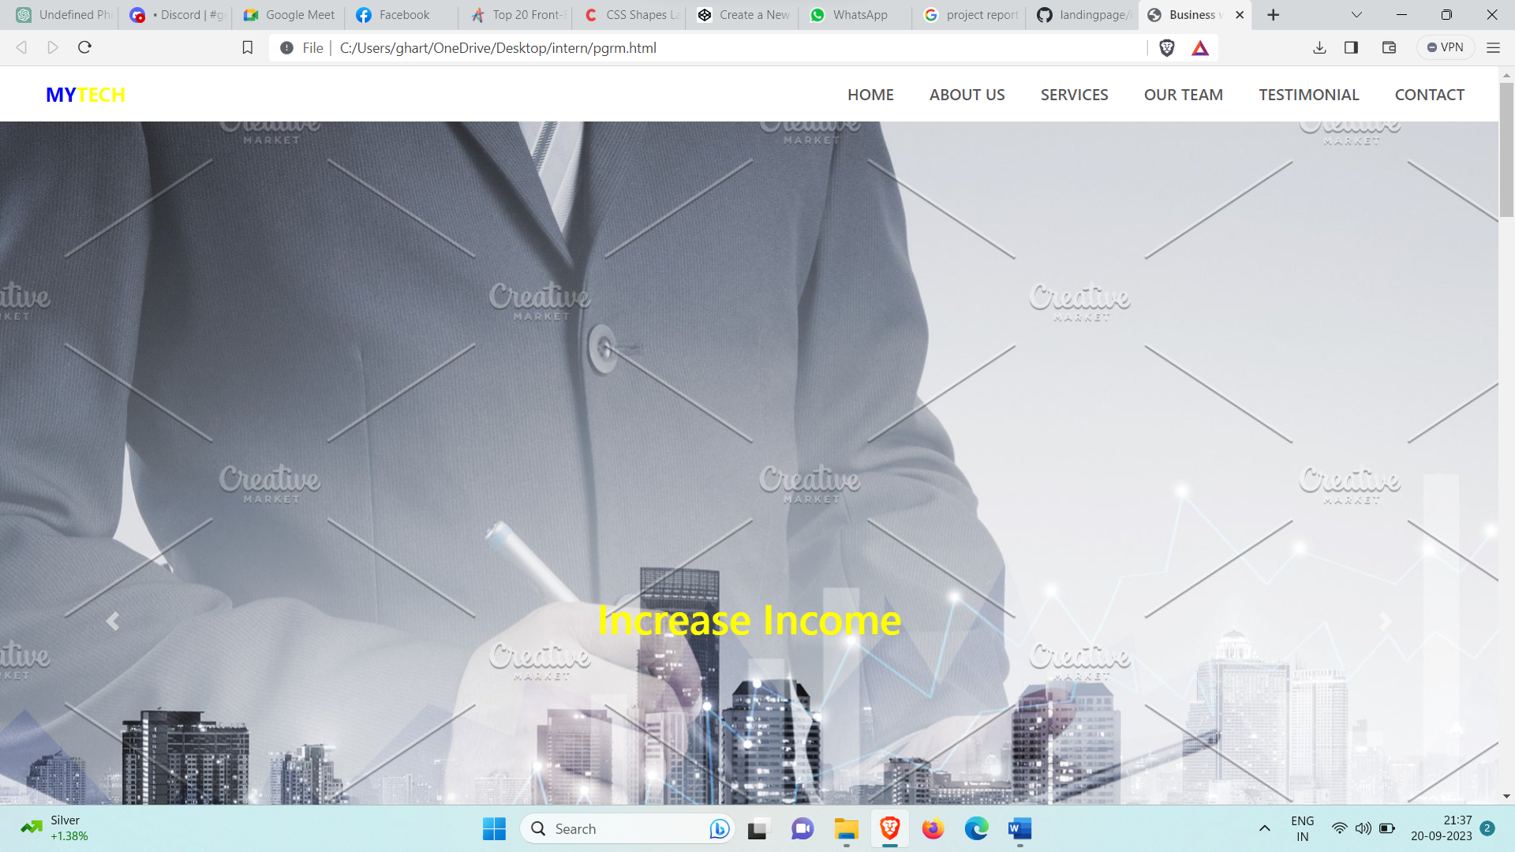

**Snap1.Home Page**

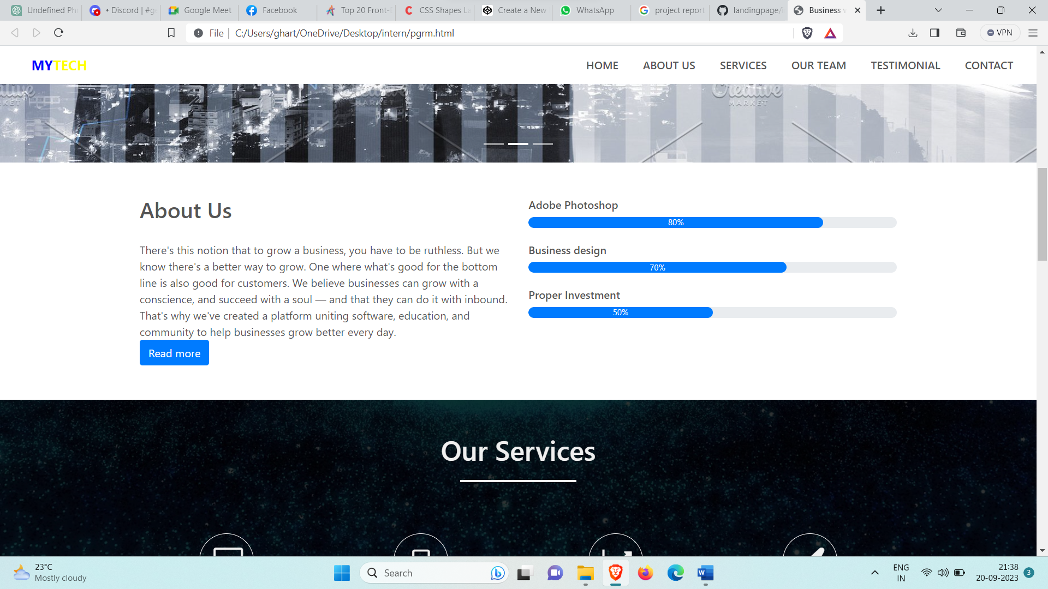

Snap2: About us

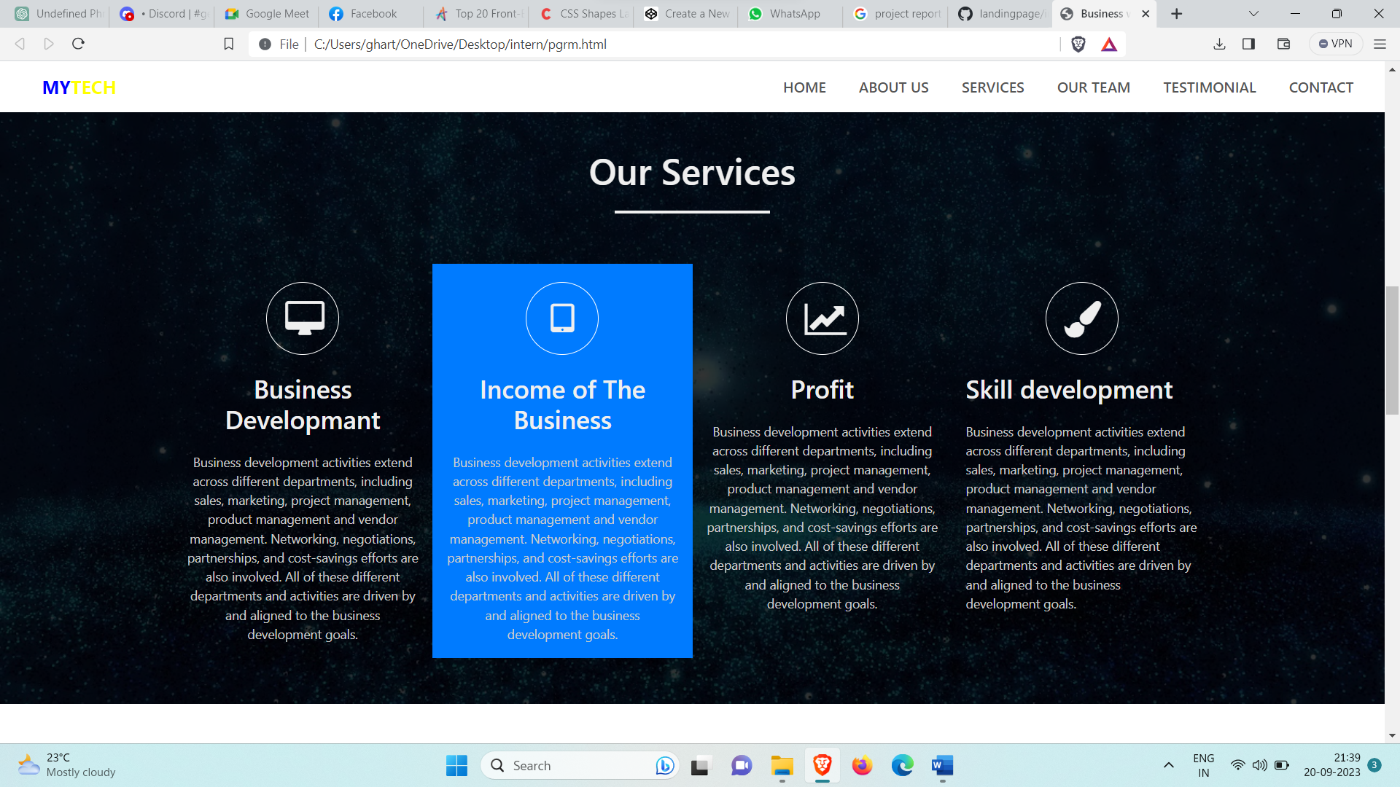

Snap3.Services

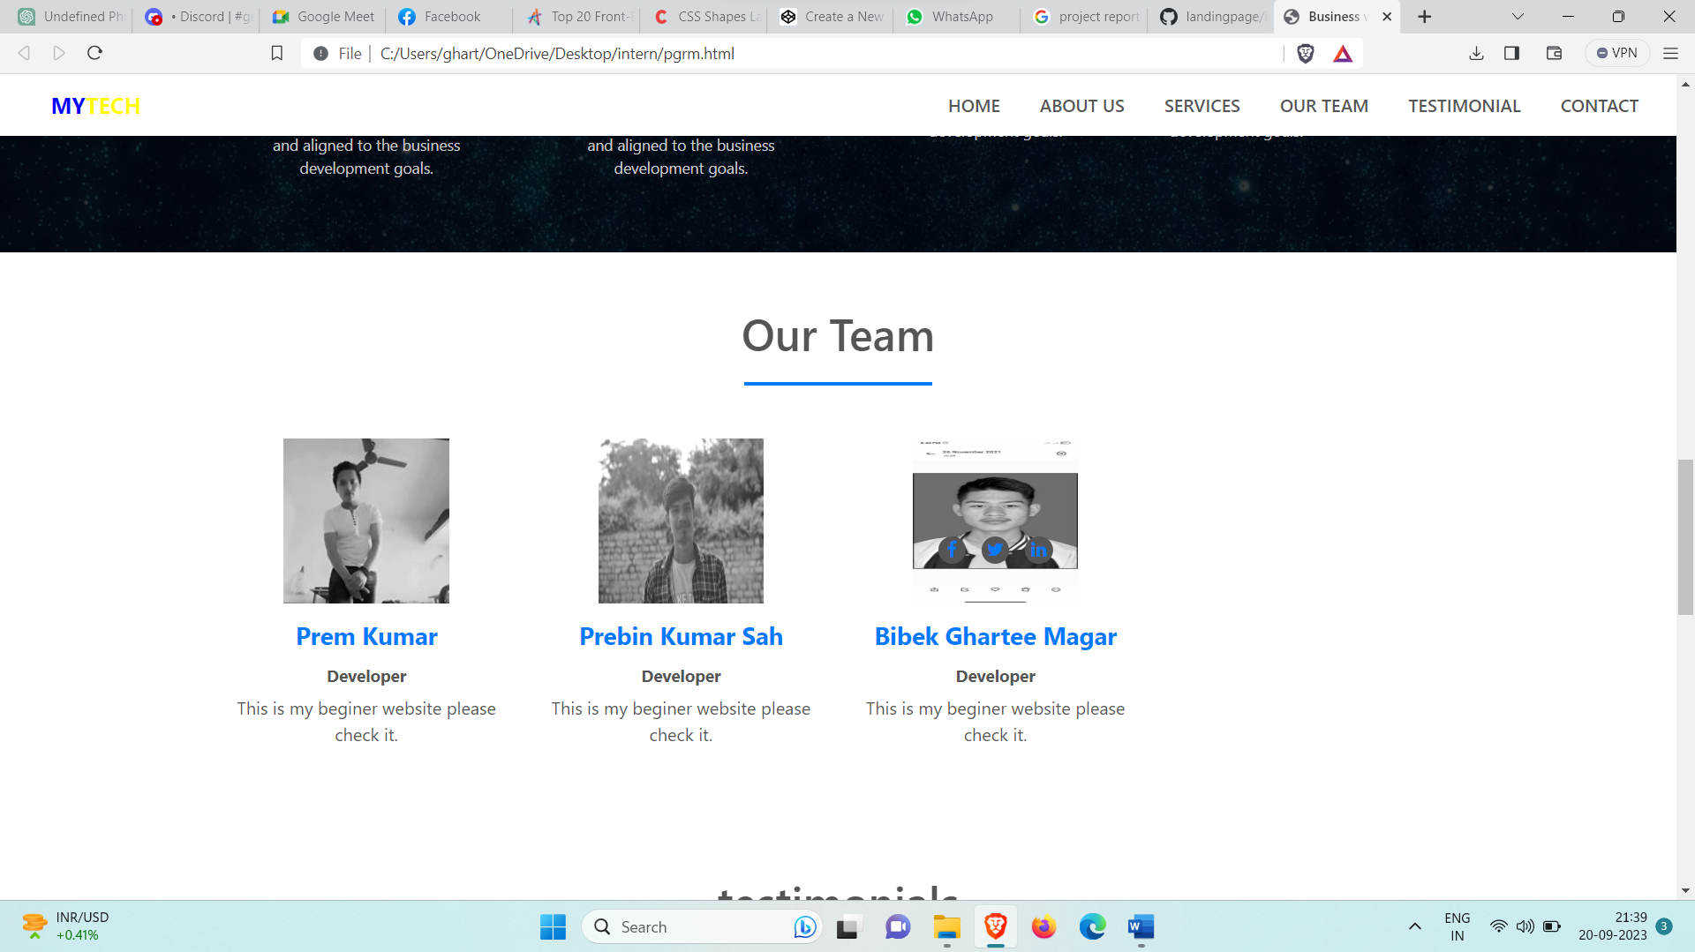

Snap4:Team Member

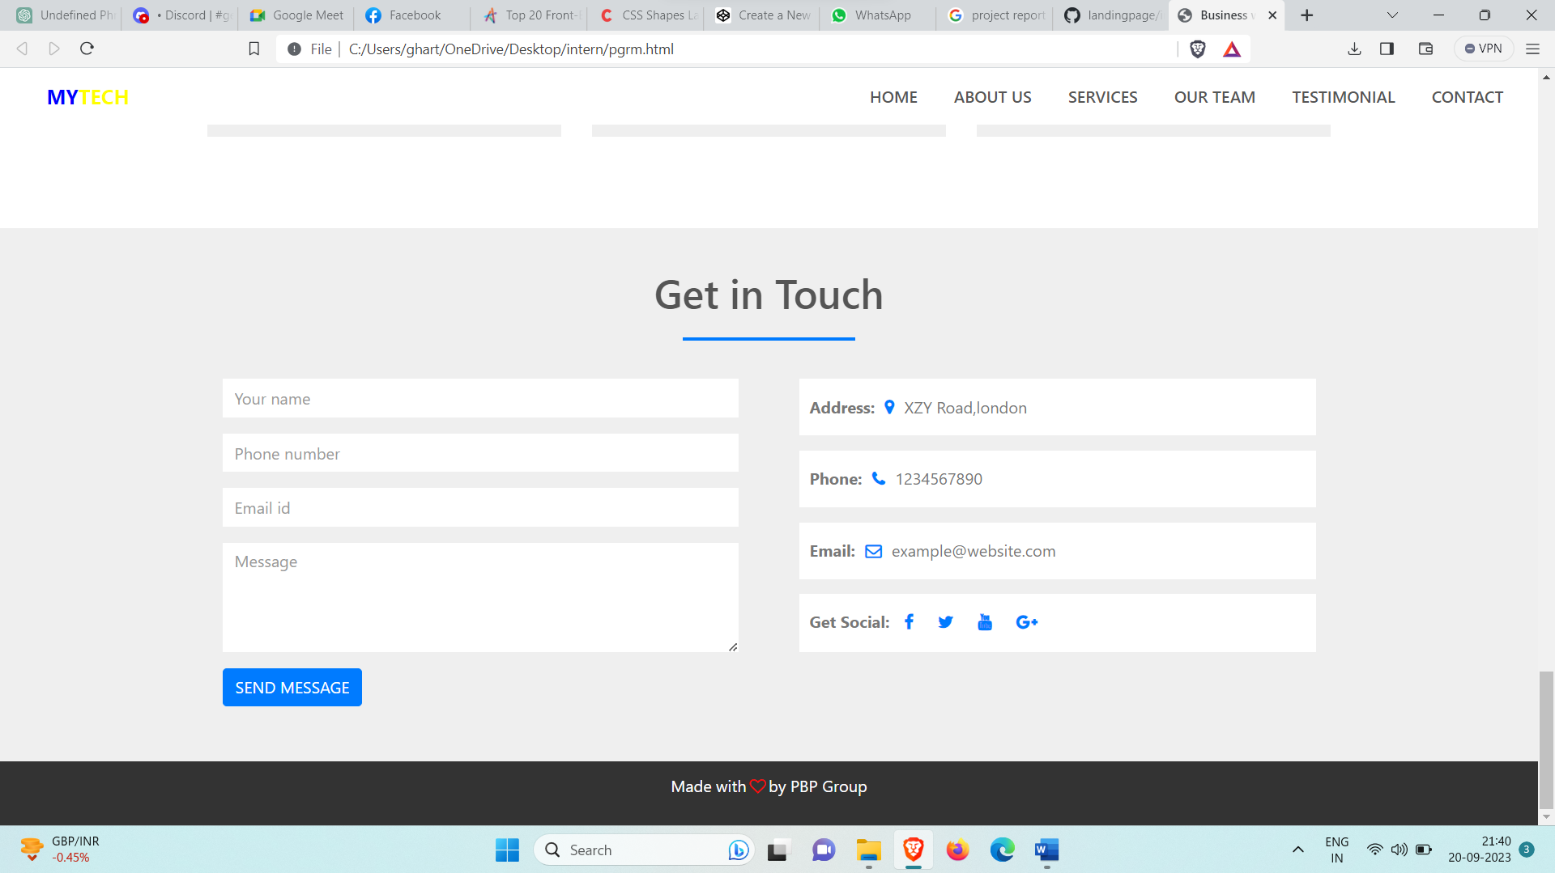

Snap5: Contact us

# [CHAPTE](https://1.bp.blogspot.com/-dODuK8N5h1Q/Wlnyb3V9HFI/AAAAAAAACL4/WxQtCJ1pM5wccDABg4wIrTBUB0vlikXQQCLcBGAs/s1600/poly1.jpg)R 9 CONCLUSION

* 1. **CONCLUSION**

The package was designed in such a way that future modifications can be done easily. The following conclusions can be deduced from the development of the project:

* Automation of the entire system improves the efficiency
* It provides a friendly graphical user interface which proves to be better when compared to the existing system.
* It gives appropriate access to the authorized users depending on their permissions.
* It effectively overcomes the delay in communications.
* Updating of information becomes so easier
* System security, data security and reliability are the striking features.
* The System has adequate scope for modification in future if it is necessary.

# REFERENCE

"Software Engineering: Practioner's Approach" by Roger S. Pressman - A comprehensive book covering software engineering methodologies, including design and analysis.

"Interaction Design: Beyond Human-Computer Interaction" by Yvonne Rogers, Helen Sharp, and Jenny Preece - Provides insights into UI/UX design principles and methodologies.

"UML Distilled: A Brief Guide to the Standard Object Modeling Language" by Martin Fowler - A concise guide to Unified Modeling Language (UML), often used in system architecture design.

IEEE Xplore (https://ieeexplore.ieee.org/) - A digital library providing access to research papers, articles, and conference papers related to design, analysis, and various engineering disciplines.

ACM Digital Library (https://dl.acm.org/) - A digital library containing a vast collection of research papers, articles, and conference proceedings related to computer science and information technology.